**Operational Amplifier II**

**Lab 12**

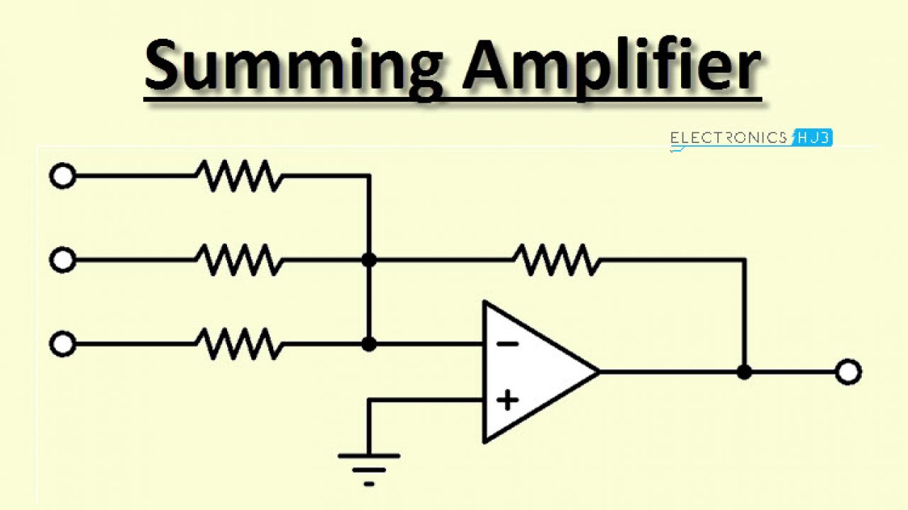

ECE 1101 Lab, Section 6

Date: Thursday, November 14th, 2019

Kyler Martinez, Daniel Tan

Equipment Used In The Experiment:

* Keysight Function/Arbitrary Waveform Generator 10Hz
  + Make/Model: 33210A
  + Serial Number: MY48017338
* Keysight InfiniiVision Digital Storage Oscilloscope 200 MHz
  + Make/Model: DSOX2022A
  + Serial Number: MY56041108
* Keysight Triple Output DC Power Supply
  + Make/Model: E3630A
  + Serial Number: MY56186189
* Keysight 4 ½ Digital Display Multimeter
  + Make/Model: U3401A
  + Serial Number: MY56150032
* Lab-Volt Power Supply
  + Make/Model: 1224 AC/Dual DC Power Supply
  + Serial Number: N/A

Materials Used In The Experiment:

* Breadboard
* 741 Operational Amplifier
* Four 10kΩ resistor
* 220kΩ resistor
* 330k Ω resistor
* Two 47k Ω resistor
* Four 100k Ω resistor

Objective:

For this part one, students will design and validate the operation of a summing amplifier.

Background Theory:

When R1=R2=R3=R the Vo of the amplifier will equal (Rf/R)(V1+V2+V3), and if Rf=R the output voltage would be negative of the sum of the voltages.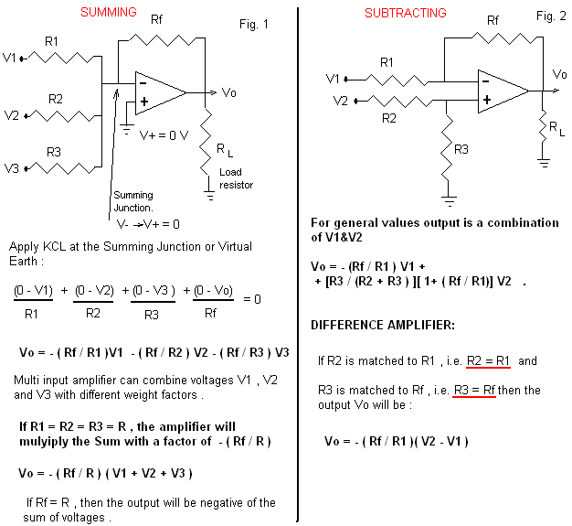

Procedure:

First, students will build the circuit shown in figure 1 with +/-Vcc to +/-15V, V1=15V, V2=-15V, V3=5V, R1=220KΩ, R2=330KΩ, R3=100KΩ, RF=47KΩ, and RL=10KΩ. Then, using a DC voltmeter, measure the output and compute the output with the equation from the background theory and compare the measured value. Next, replace R1, R2, R3, and Rf with a 100kΩ resistor and compare the measured output with the calculated one again. Revert the setup to how it was in figure 1, and calculate a new resistor value for R2 where the output would be 0. Replace the 330kΩ resistor with one with the new resistor value and measure the output. Now, replace V3 with a 4 Vpp 1kHz signal and record the output. Finally, measure the voltage at the Virtual Earth.

Data:

Vo was measured to be -3.3835V, while the output was calculated to be -3.4182V, which resulted in a discrepancy of 1.02557%. After making all resistors equal to 100kΩ, is Vo was found to be -2.3526V while the calculated voltage was found to be -2.35V, with a discrepancy of .1106%. We calculated the value of about 127kΩ, rounded to the nearest whole number, for R2 so that Vo would theoretically be zero when we measured Vo we saw -10mV which is close to the value we were wanting. After changing the input of V3 to a sinusoidal wave, we observed an output voltage of 1.93V. We also measured the virtual earth and got a measurement of 1.24mV

Oscilloscope Reading of Vo

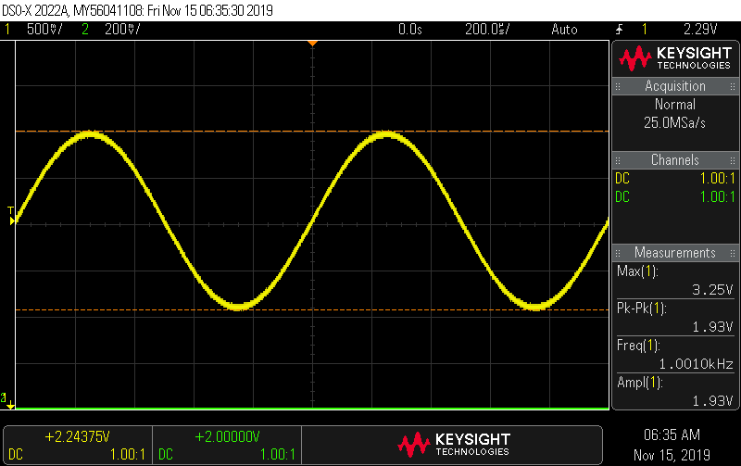

Conclusion:

Overall, we were able to get values consistent with the background theory, leading to low percent errors with many around a couple of percent. For our 330kΩ resistor and 127kΩ resistor we had to use multiple resistors in order make an equivalent resistance to equal those values. Other discrepancies are the result of the operational amplifier not being perfect with allows for the values to be slightly different than our calculated values. Some other factors that could have affected our results were other electromagnetic forces and some components not being added to our breadboard properly. The lab was a success and we gathered good data.